How to use Enter Serial Macro 3.43

How To Use

1. Open the “Enter Serial Macro” program

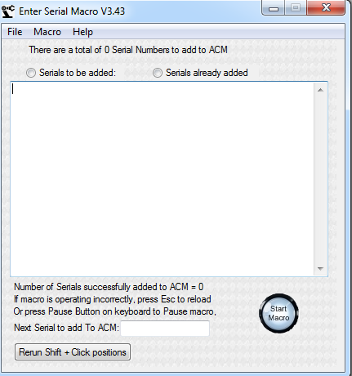

1. In the Pubtool Effectivity screen, select the “Affected” effectivity that is needed. Make sure to include all the information as shown in the examples shown below.

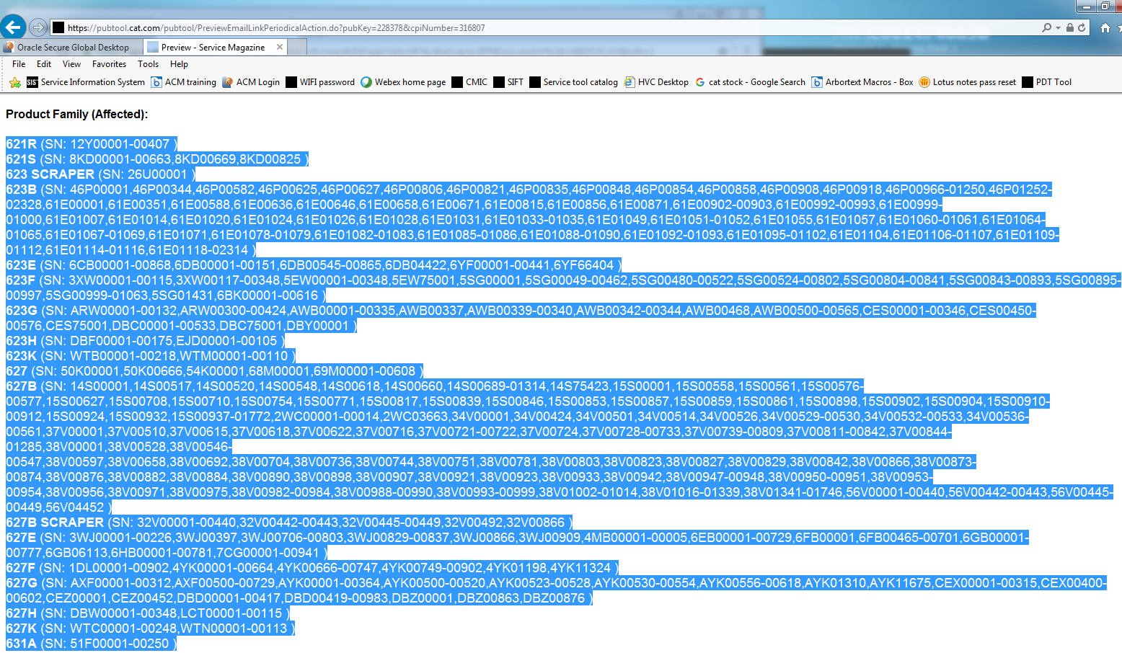

Example 1

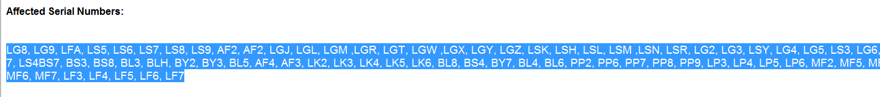

Example 2



Example 3

1. With the Enter Serial Macro program open, Press Ctrl + 1 in the PDT tool screen, the macro will copy all the selected text. The macro will then automatically format and paste the text into the Enter Serial Macro window
2. 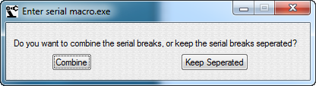

The window above will appear asking if you want to keep all the serial breaks or to combine them to one single serial per prefix. (The lowest and the highest # per prefix)

1. Open ACM and navigate to the desired IE Effectivity screen. Maximize the ACM effectivity screen. Maximizing the screen helps with the reliability of the macro. See image below.

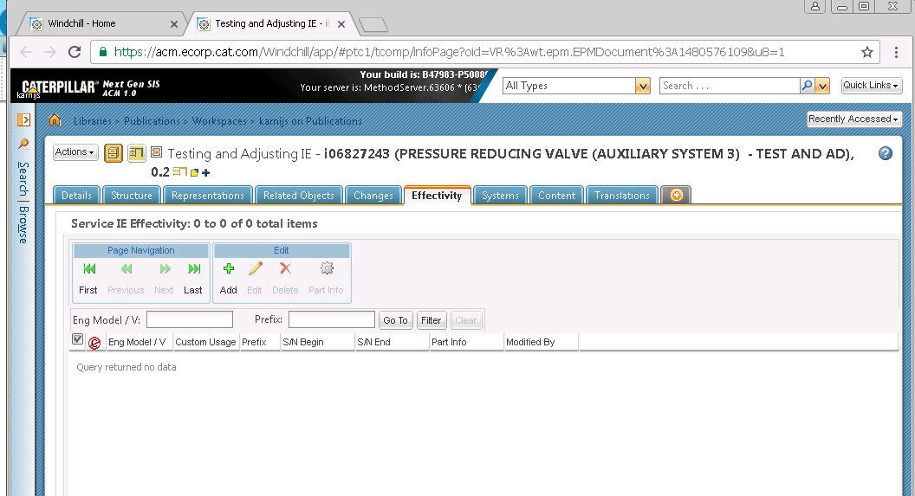

1. Within the Effectivity screen, Press Ctrl + 2 or click on the  button on the Serial Macro window. You will be asked to maximize the ACM window just as a reminder.
2. A tooltip will be shown under the mouse cursor giving instructions. This tooltip is shown in the image below.



* 1. Hold down the shift key and then click on the “Add’ button in the effectivity Screen. See image below.

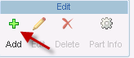

* 1. After that action is performed, a new tooltip will be shown under the mouse cursor a few seconds later as shown below. Hold Down the shift key and then mouse button click on the “Prefix edit box.



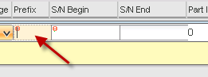

* 1. After that action is performed, a new tooltip will be shown under the mouse cursor a few seconds later. This tooltip is shown in the below image. Hold down the Shift key and then mouse button click on the “Apply” Button. These actions allow the macro to find where those buttons are located on your screen for later use.  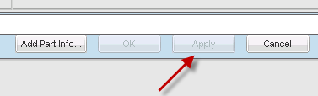

1. Soon afterwards, the macro will automatically begin to enter the information from the Enter Serial Macro window and into the ACM screen. During this process, if you move the mouse or try to type, the macro will automatically pause at the beginning of a new cycle. The macro will wait for 5 seconds of no activity before it resumes. DO NOT lock the computer it as it will mess up the macro. If you need to pause the macro, you can press the Pause or Insert key on the keyboard, and the macro will pause. You can resume the macro by pressing the pause button on the Enter Serials window, or by pressing the pause or insert button on the keyboard. After about 20 serial number additions to ACM, the macro will refresh the ACM screen and click on the Add button to continue entering serial numbers. This prevents the issue with ACM when many serial numbers are added and the server slows down.

Time-Out Screen

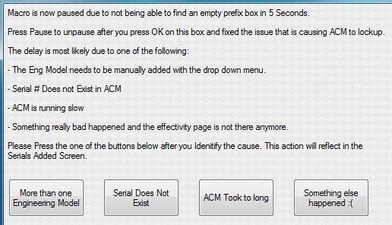

After about 5-7 seconds when the serial is entered into the ACM screen and the macro cannot detect that the serial was not successfully added, a popup window will show up saying the macro is now paused and directs you to look into what caused the macro to time out. Below are the options to choose from. Selecting the correct reason will ensure that that serial prefix for the session will not cause the macro to time out again. The macro will log the prefix based on your selection to prevent more pauses from that serial prefix.

* Select “More than one Engineering Model” if there is more than one model associated with the Serial Prefix.
* Select “Serial Does Not Exist” if the serial prefix is not in ACM.
* Select “ACM took to long” if the time-out was caused by ACM server being slow.
* Select “Something else happened :(“ for all other reasons.

# More than one Engineering Model

If the “More than one engineering model” button is selected, a window will display asking to select the engineering model number and then to press the OK button. The macro will resume after the OK button is pressed. **DO NOT press OK and then select the Engineering model. Select the Engineering Model first, then press the OK button.**

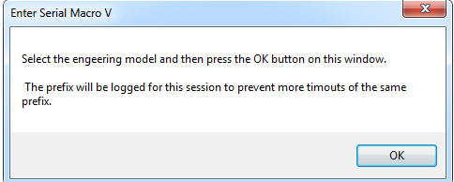

The prefix is logged and will create the following window when the serial is entered again into ACM.

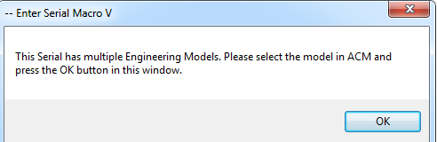

Select the engeering model according to your Pubtool serial list. You may have to select the Sales model first to pick an engeering model.



# Serial Does Not Exist

If the “Serial Does Not Exist” button is selected, then the prefix is logged and will be skipped over in the macro.

# ACM took to long

If the “ACM took to long” button is selected, the instance will be logged and the macro will continue.

* + After two instances of this, Macro will increase time-out time by 1 second.
  + After the time increase, if there are two more instances (total of 4) of ACM being slow, an additional second will be added to timeout time.
  + After two more instances (total of 6), macro will refresh ACM after 10 serials instead of 20 to try to help with server speed.

# Something else happened :(

If the “Something else happened :(“ button is selected then a new window will display asking if the problem was resolved. If you find and correct the issue, then press Yes and the macro will resume, if you cannot correct the issue, then press No and the macro will stop.

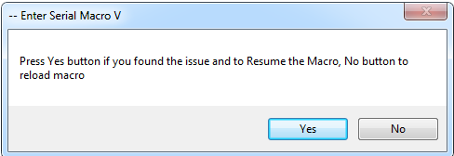

Macro Window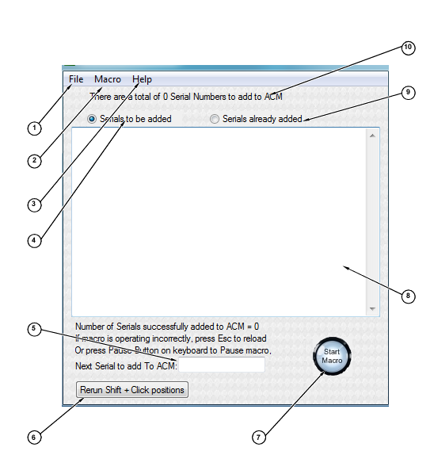

1: File menu

Check for update -> checks for an update of the macro

Quit -> Quits macro

2: Macro menu

Run -> Starts the macro

Pause / Unpause -> Stops the macro in mid process

Stop Macro -> Stops the macro and ends the current session

Reload Macro -> Reloads the program to start a new session

3: Help menu

How to use -> Brings up this PDF

About -> Displays the contact information for bugs and enhancement requests

4: Once selected, box (8) will display the serials that were formatted and ready to be entered into ACM

5: Shows the next serial that will be added to ACM.

6: Button resets the Shift-Click procedure.

7: Button to show program status.

8 Display box that allows user to view, edit or copy content

9: Once selected, box (8) will display the serials there were entered into ACM, as well as the logged bad serials.

10: Displays the amount of serial prefixes that were formatted.

Change Log

3.4

* Added ACM to slow button in Time-out window
* ACM timed out button selection eventually increases the timeout time
* Added button to main window to reset the Shift + Click Procedure
* Updated how to use manual.

3.3

* Removed the use of notepad, to simplify the process.
* Added auto pause before next cycle if user activity exists.
* Made brand new interface window
* Added logging for all serials entered, not just the last 10
* Now able to handle if the serial is not in ACM or if there are multiple Engineering models.
* Updated how to use manual.

3.21

* Started this change log
* Made macro to handle a left or right mouse button click when selecting the Add button, prefix box, and apply buttons. Updated how to use file with this change. This helps out if someone has the mouse buttons switched for left hand use.
* Moved notepad opened check to beginning of the Ctrl+2 sequence. If notepad it not opened, a dialog will pop up asking if you want to open Notepad
* Made closing out of the GUI screen, quits app. A confirmation box will appear so no accidents happen.
* Removed a hidden hotkey that was set for testing purposes that I forgot to deactivate in the V3.2. It can cause issues in other programs if the macro wasn’t closed.